Notice that all the right is to Stanford University cs231n

the youtube URL : <https://www.youtube.com/watch?v=h7iBpEHGVNc>

**[Linear Classification - cont’d]**

- then, how can we get the best W? we have to use Loss function and Optimization.

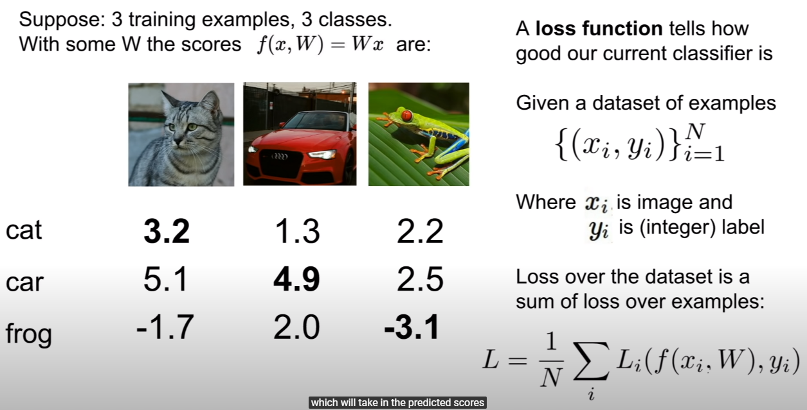

- fuction f is prediction givein W and x which is input. after prediction, we compare it to y_i which is label. by summing all the L_i and taking average, we can get an accuracy.

> so we have to minimize the L.

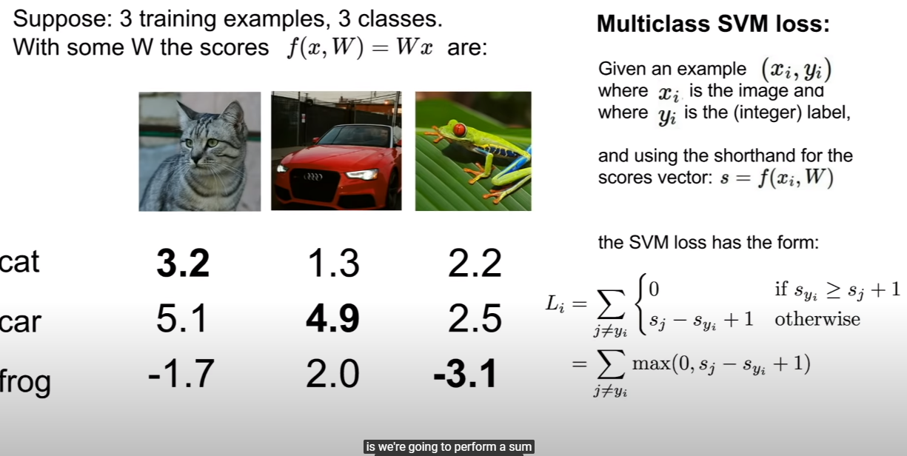

- Multiclass SVM Loss works like, if true class(correctly classified) score is higher than others, take 0, otherwise that s_j+s_i+1 which is error.

- so if it is mis-classified, take error and averaging as a L(total error).

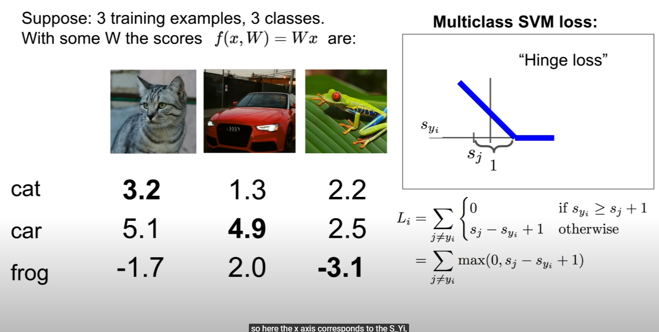

- s_yi(axis x) is the score of the true class for some training example.

> s_i is predicted score.

- so before we reach after safety margin(1), the loss decrease linearly.

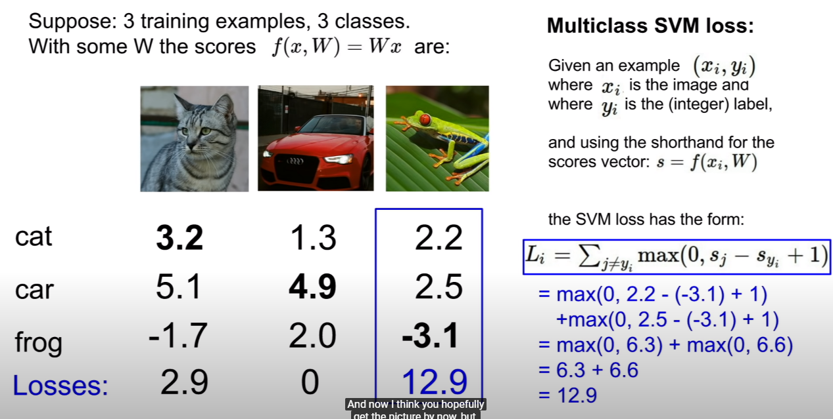

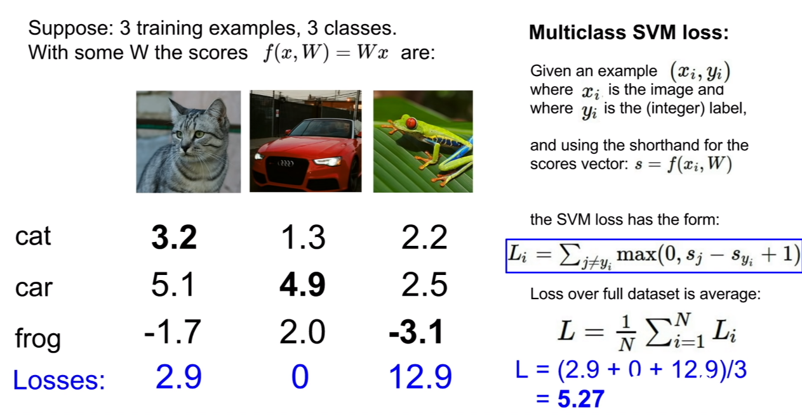

- In above example, out Multiclass SVM is 5.27 bad on this data set.

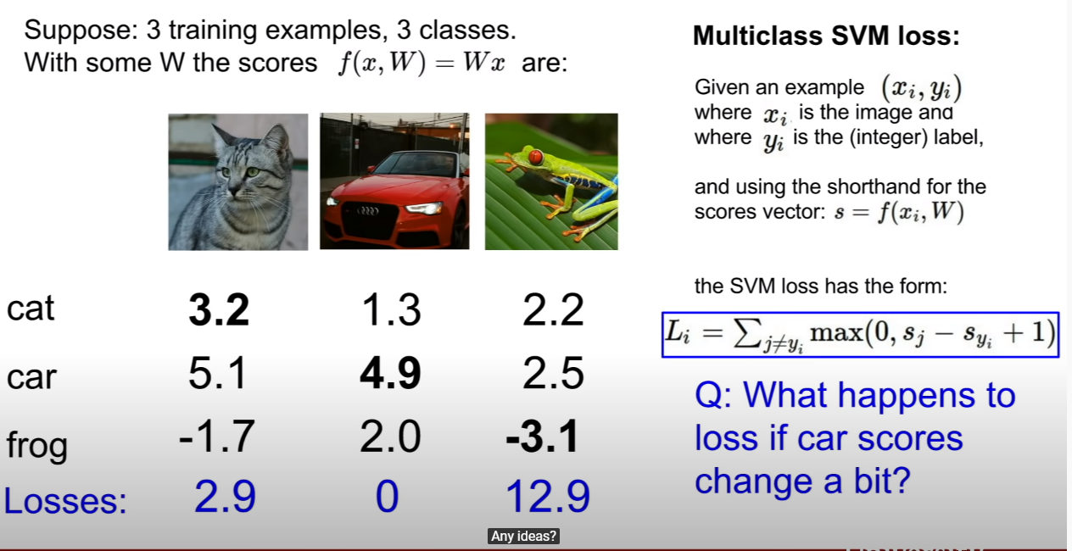

- even if we jiggle a score of car, there is no change. since SVM Loss doesn’t care of correct classified value.

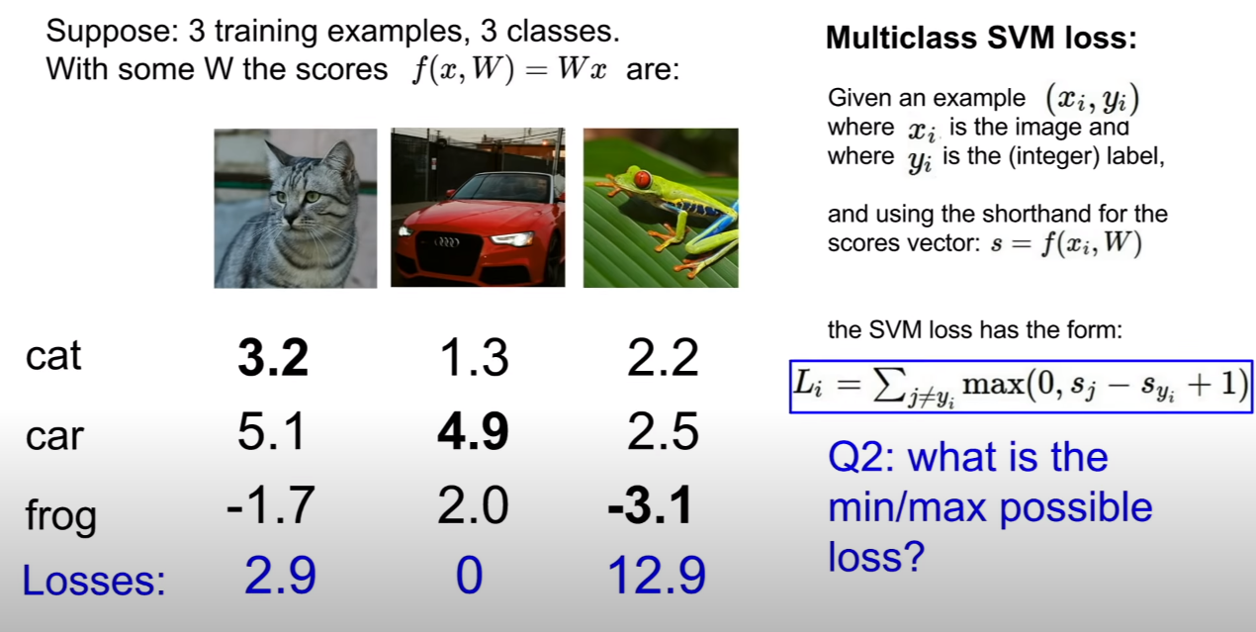

- the answer of this question is, minimum is zero since when across all the classes, our correct score is larger, then loss is zero. And maximum would be infinte by refering to hinge Loss.

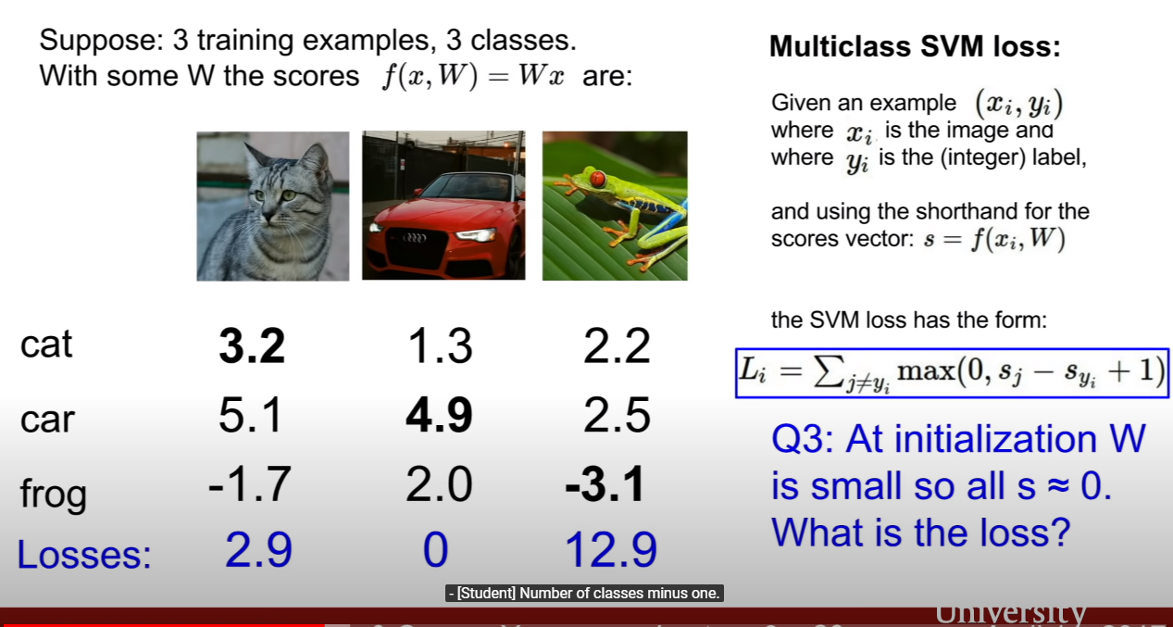

- the answer is the number of classes – 1. it’s going to be useful during debugging at first.

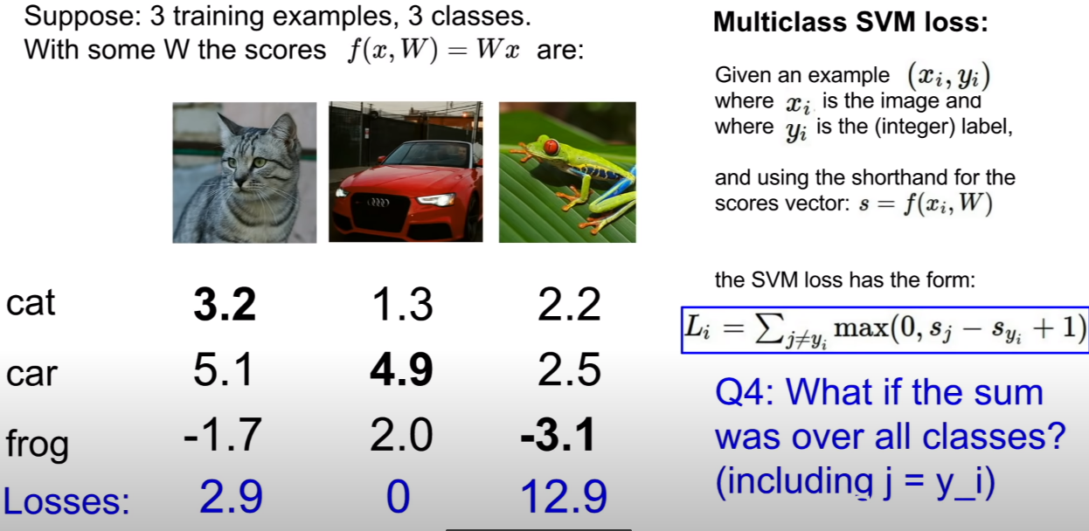

- the answer is loss will be plused by one. since in correct classified data, max(0,s_j-s_yi+1)= 1. after summing all the correct data, we take mean value, I mean, we have to divide it by n. so the loss will be plused by one.

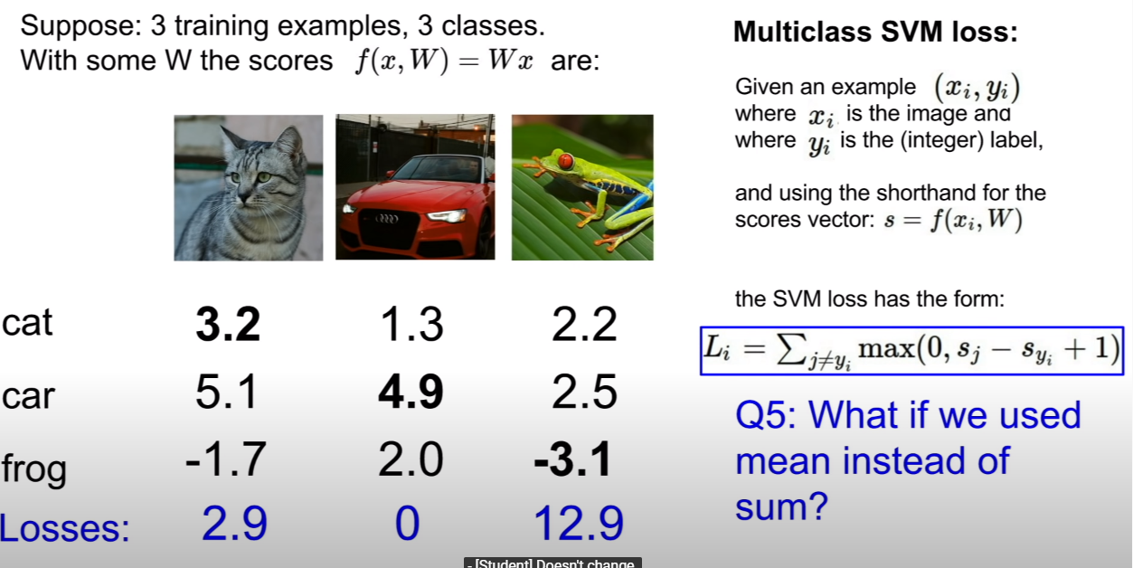

- the answer is loss doesn’t change.

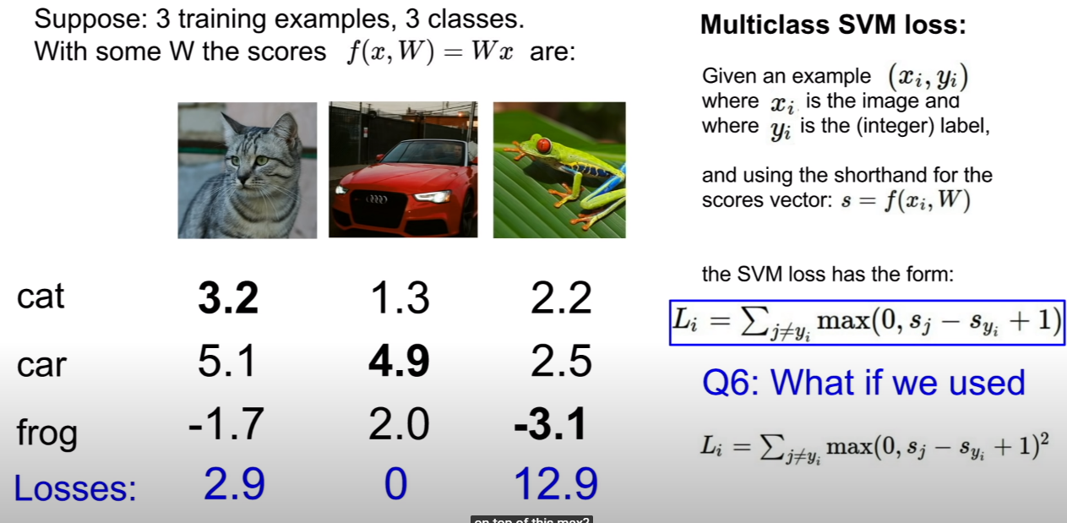

- this would be a diferent classfication algorithm. we are changing the trade-offs between goods and bads in nonlinear way, this would end up computing a different loss function.

> the point is how significantly will you give a panalty to uncorrect classification. so if we use squared loss function, we can give a more panalty.

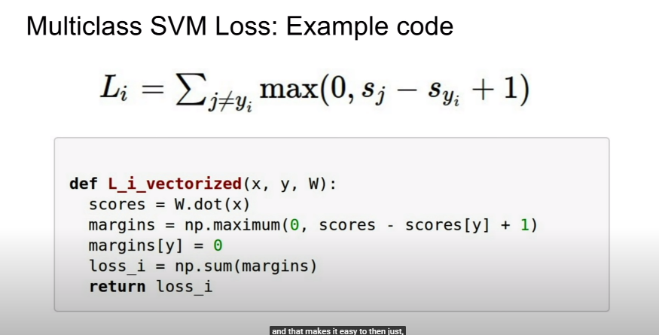

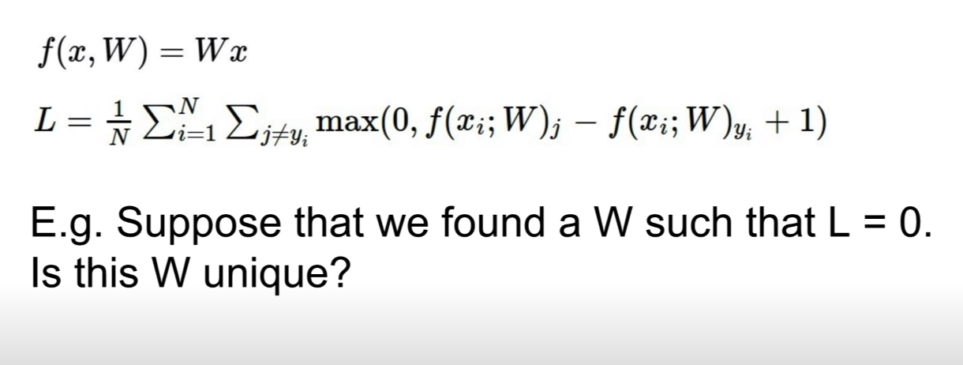

- the answer is NO, I think. since 2 * W is also L=0. like below.

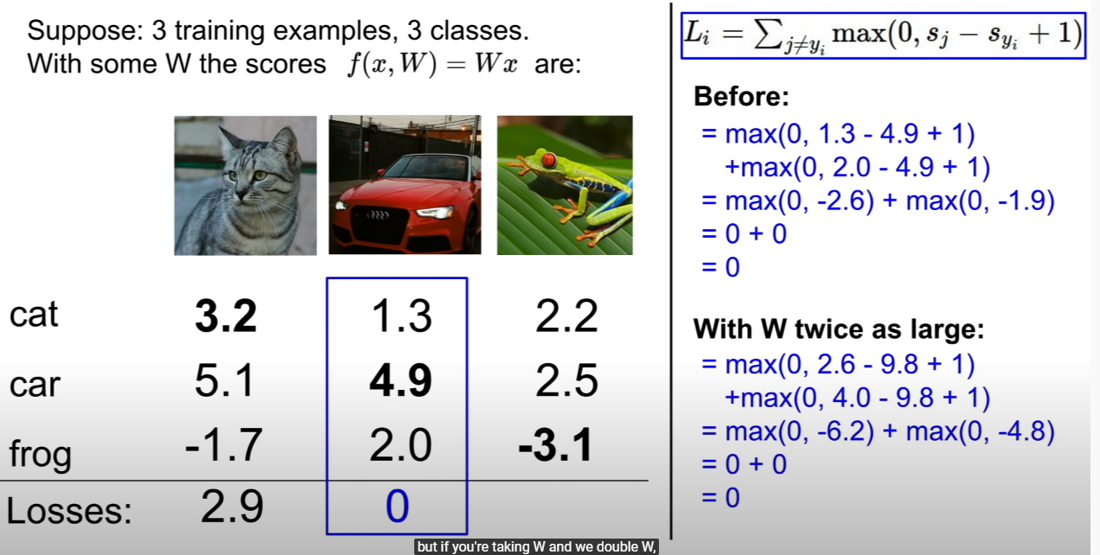

- but the point is, acutually we don’t much care of Loss on training data, so we don’t need to fit our W on training data.

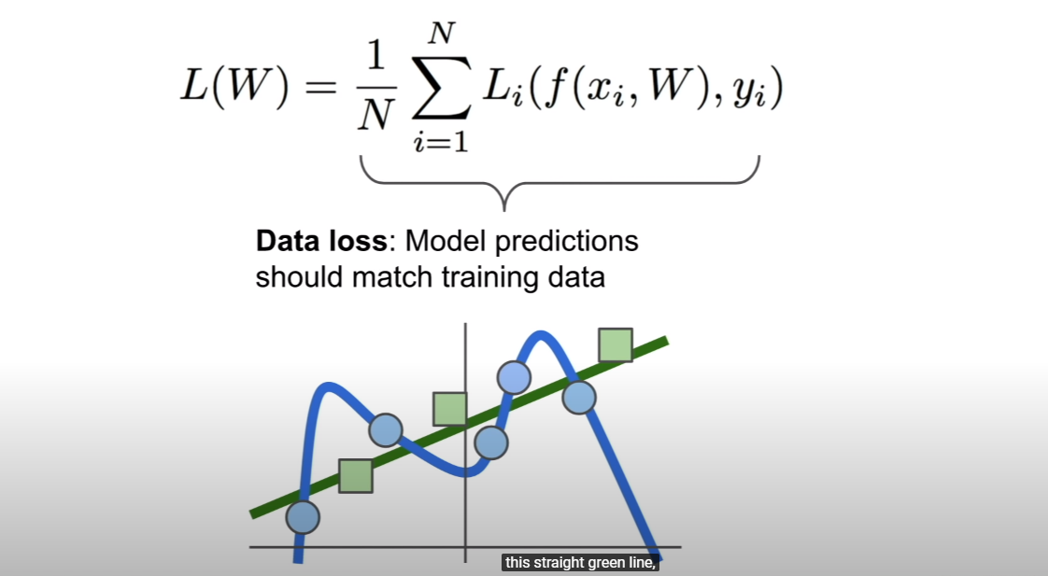

- like above, we need the green line to classify new test data, but not blue line that is overfitted to training data.

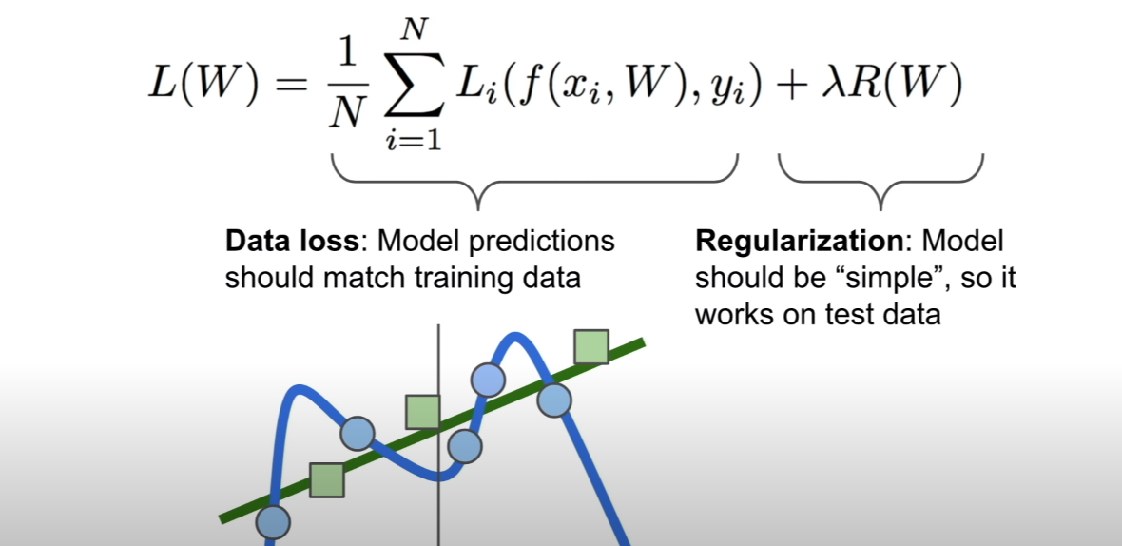

- so to solve this problem, we usually use regularization.

- the lambda is hyperparamerter, and it will be one of the most important ones to tune the model in practice.

> lambda used for like if you want to access a complex model, you have overcome a panalty given lambda!

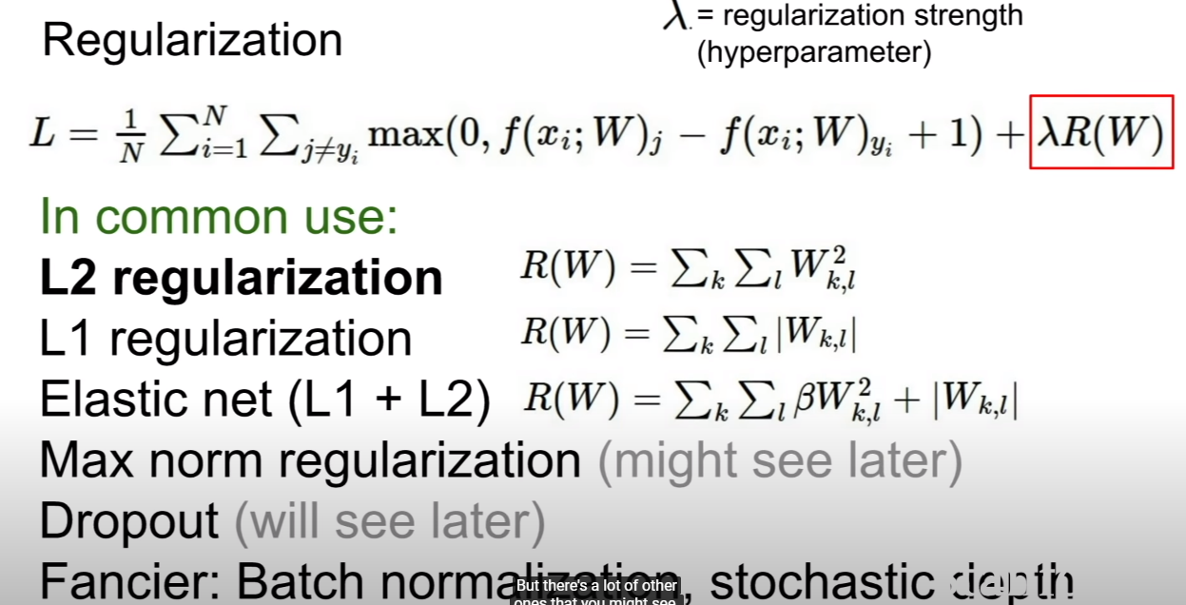

- the purpose of regularization is give some penalty to prevent overfiitting on training set. it means that regularization prevent making polynomial regression to fit trainset. since we need linear regression for new unseen test set.

- L2 regularization is kind of more robust, for example, when there are W1=[1,0,0,0] and W2=[0.25, 0.25, 0.25, 0.25], they make same result, but by applying L2 regularization, it spread the influences across all the different value x. <- I don’t understancd :(

> easily, I think L2 regularization consider all the value in x, but L1 just consider a specific value in x. so it’s like one man team for L1 and normal team for L2.

> the lecturer said, L1 prefers sparce solutions.

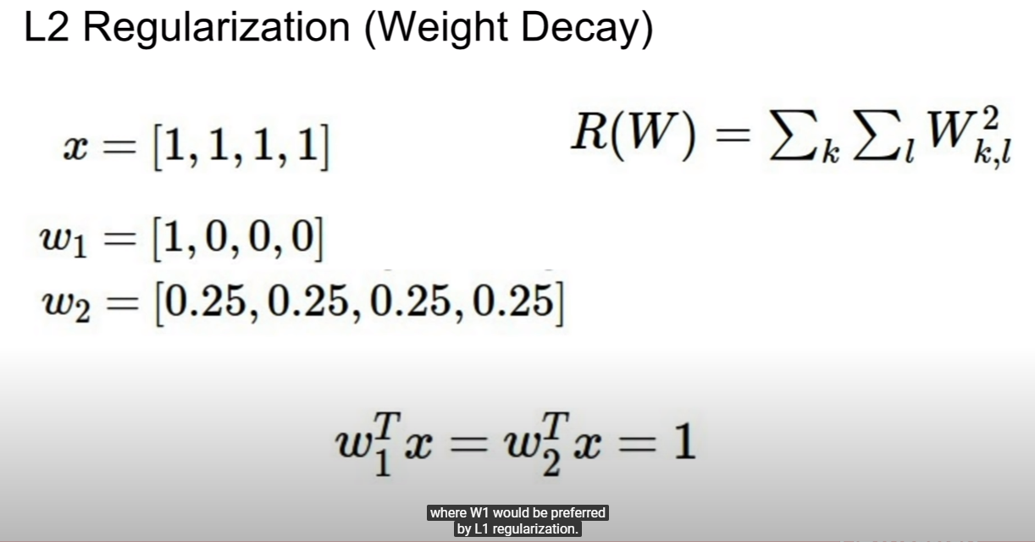

**[softmax loss – multinomial logistic regression]**

- whereas multi-SVM loss create score that doesn’t have intuitive meaning, softmax loss’s score has meaning that is probability.

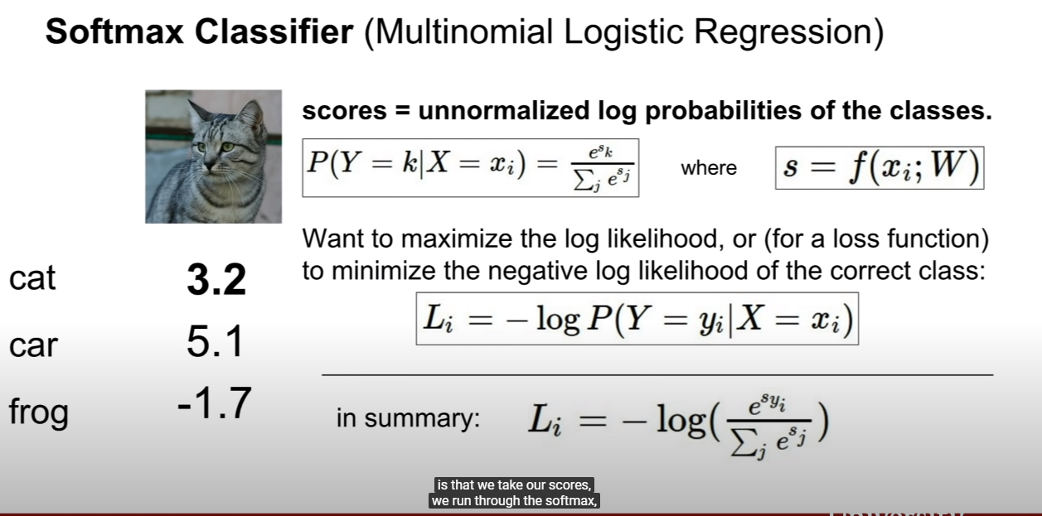

- Loss means error, so we take minus(-).

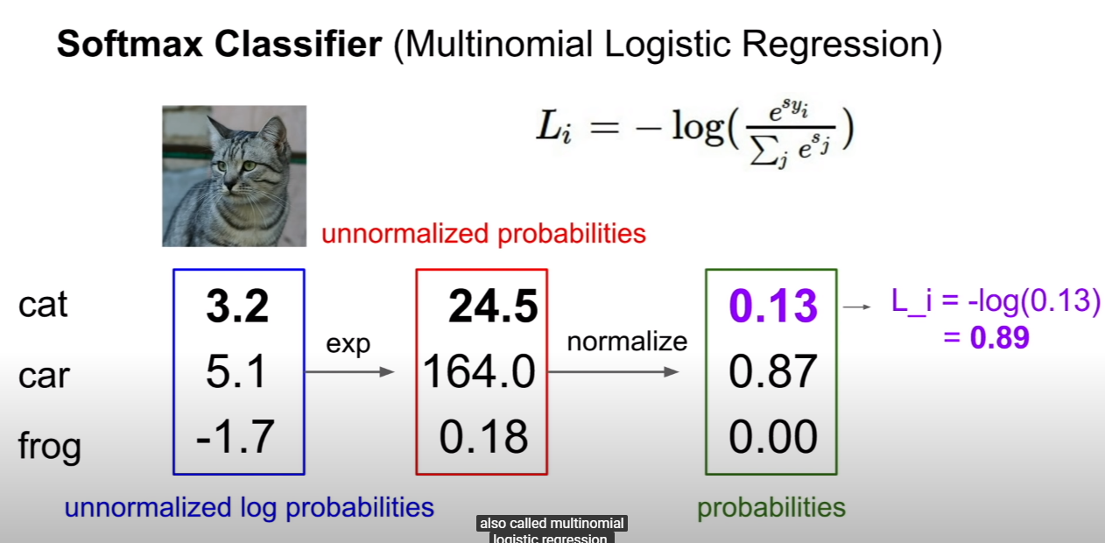

- above ficture shows how we can get loss.

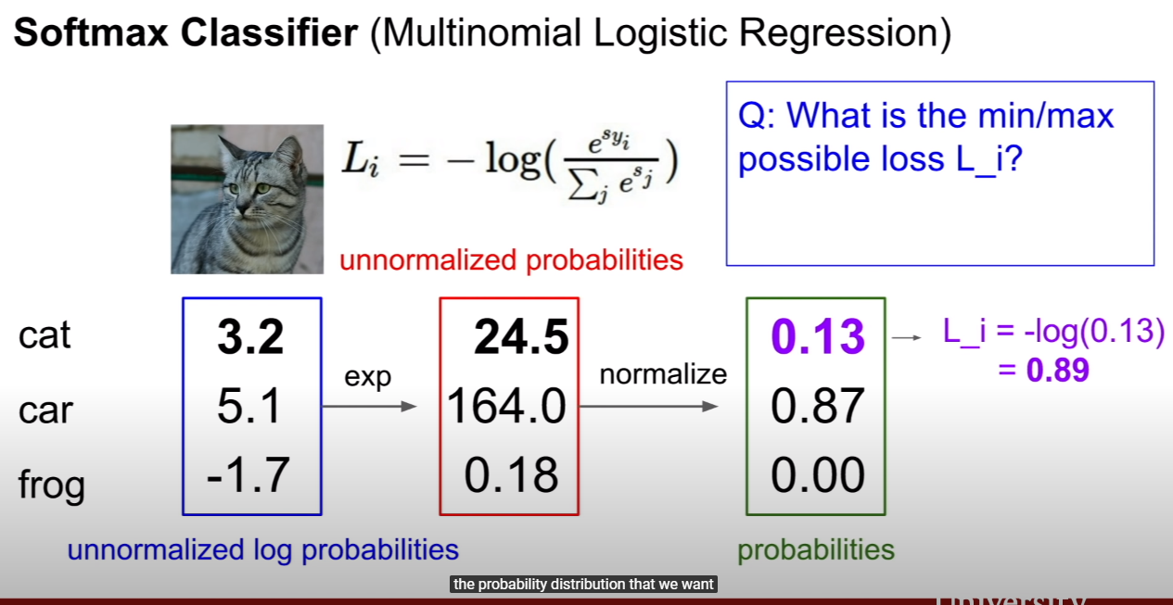

- min loss could be zero, max loss could be infinite.

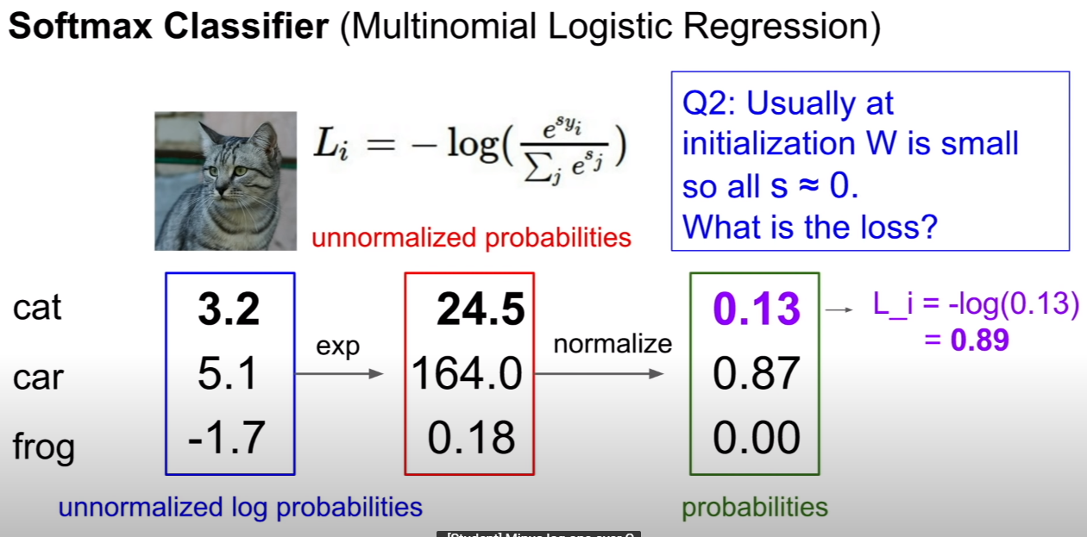

- the answer is log of C.

